**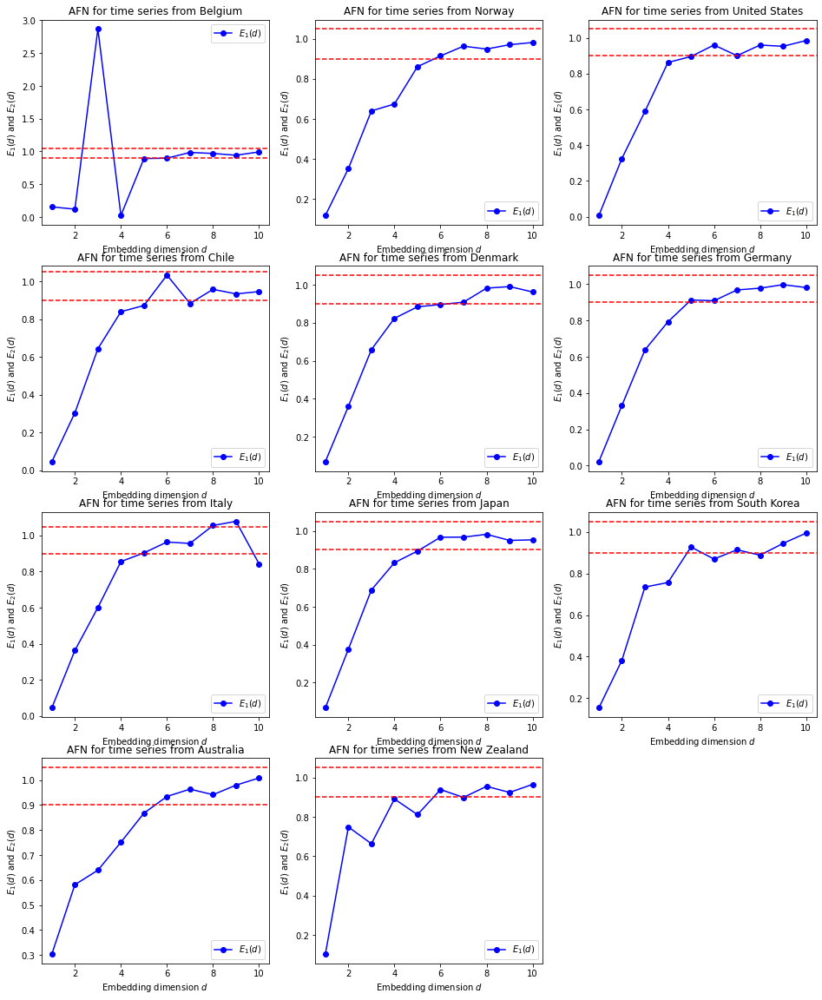   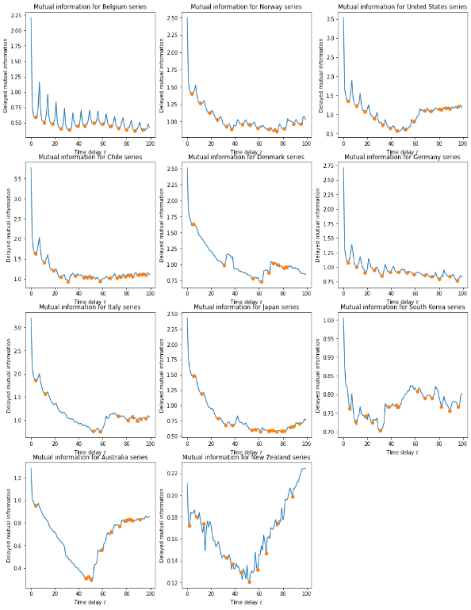**

**Figure Supplementary 1.** Curves to compute the minimum embedding dimension and the time delay for the series of incidence of the 11 considered countries.

**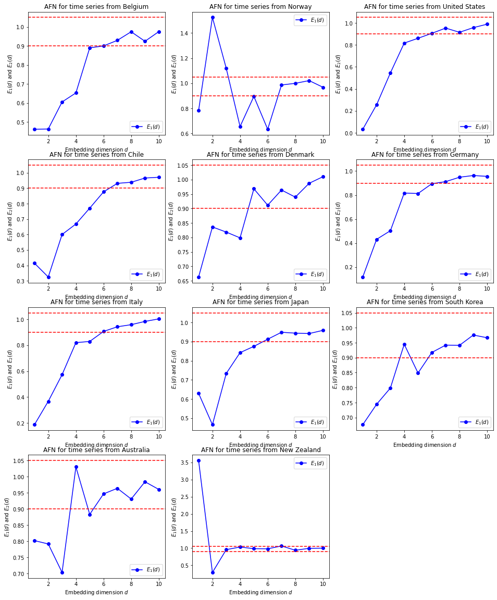   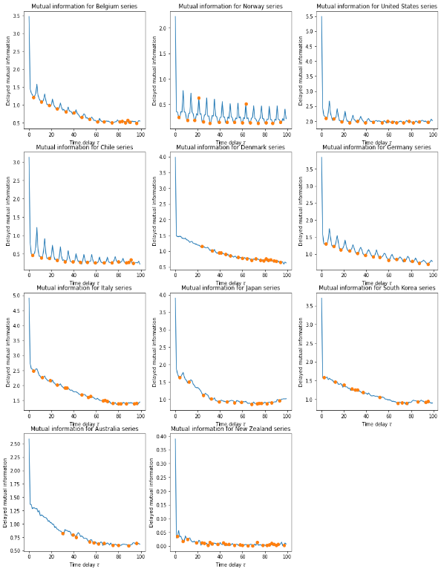**

**Figure Supplementary 2.** Curves to compute the minimum embedding dimension and the time delay for the series of deaths per 100,000 inhabitants of the 11 considered countries.

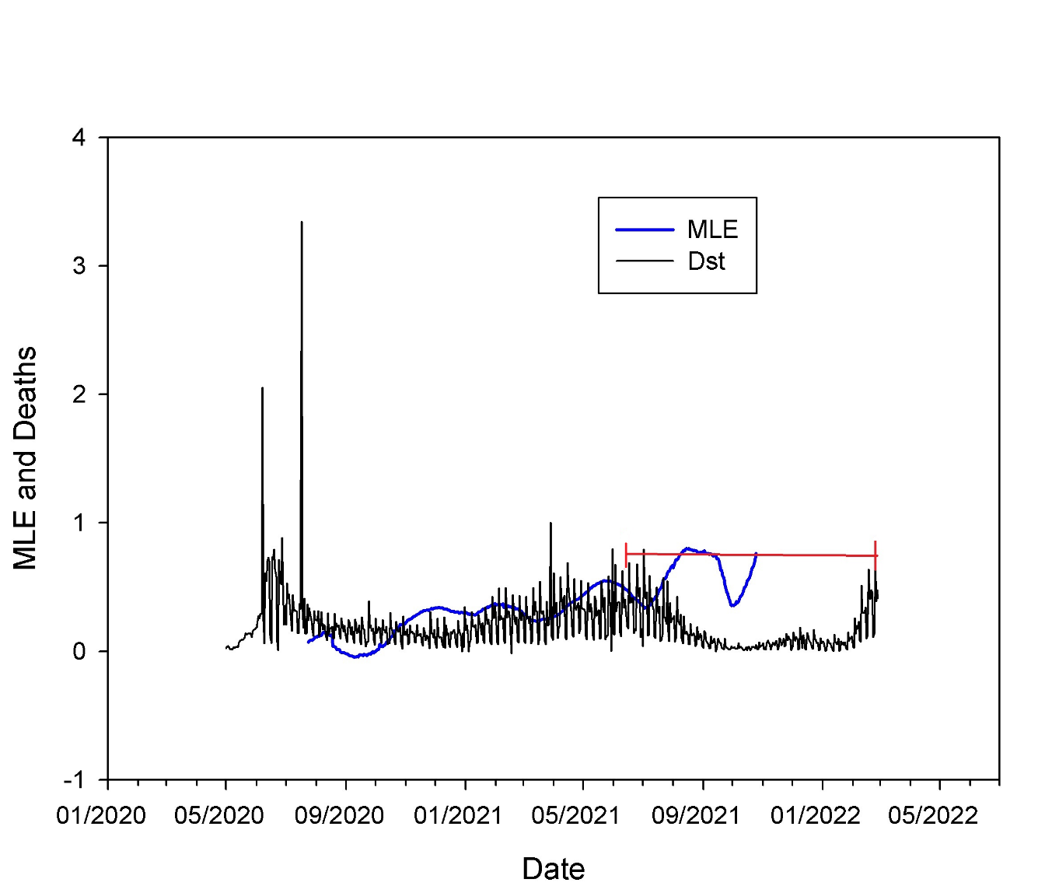

**Figure supplementary 3**. Maximum Lyapunov exponent (MLE: blue line) and standardized deaths (Dst: number of deaths/316; arbitrary value to make MLE and Deaths comparable in the figure) (black line) vs Date in Chile. The red line shows the time window to estimate MLE.